CAVCO SALES
Office: 620-767-7273 Mobile: 785-466-0189 Fax: 620-767-5303

Visit our Website & View All Our Machine Pictures: www.cavcosales.com

E-Mail Us: cavco@tctelco.net
Visit Our E-Bay Store At: http://stores.ebay.com/e-cavco

June 1, 2019 Pictures Are Available On-Line at www.cavcosales.com

We Are Distributors For The Following Manufactures

Goodson Products - Regis Manufacturing - Peterson Machine Tool Parts –
Kansas Instruments Parts - Kwik Way Boring Bar Repair Parts & Supplies – Peterson & Van Norman Boring Bar Repair Parts - BHJ High Performance Fixtures & Tooling

Used Equipment List

Crankshaft Equipment

CA1701 Camshaft Checking This Is A Piece Made For Checking Bend and Lobe Lift On Camshafts. 475.00
Station Comes With: 1” Travel Dial Indicator, 2-Sets Centers, Quick Lock/Set-Up Tailstock,
34” Length Capacity

CA1871 Wheel Balancing Stuhr, 36” Capacity, Excellent Condition. 565.00
Stand

Connecting Rod Equipment & Tooling

CA1942 Piston Pin Press PMW Open Throat 10 Ton Pin Press, Air/Hydraulic. 1,475.00
Comes With: Press Plate & Ener-Pac Detachable Pump Unit.

CA1731 Mandrel Storage Sunnen Model CRG-600, Fair Condition, Cleaned & Ready. 365.00
Cabinet

CM6002 Mandrel Storage Sunnen Model CRG-600, Fair Condition, Cleaned & Ready. 425.00
Cabinet

CA2021 Large Rod & Cylinder Sunnen AN-600, In Good Condition. 645.00
Honing Mandrel

CA2082 Rod & Cap Grinder Sunnen Model CRG-500, 115v. 645.00

CA2077 Rod Checking Fixture Sunnen Model TN-111. Red Unit, Excellent Condition. 575.00
Comes With: TN-46A For Pistons, TN-50A For Rods With Pins, TN-40A Bending
Bar And TN-120A Midget Rod Fixture.

CA2078 Rod Checking Fixture Sunnen Model TN-111. Red Unit, Good Condition. 415.00
Comes With: TN-46A For Pistons And TN-50A For Rods With Pins.

CA1925 Precision Rod Sizing Sunnen Model AG-300 Precision Sizing Gauge. 1,095.00
Gauge Comes With: 2-Calibration Rings, Adjusting Wrench, Medium & Large Points &
Wrist Pin Comparing Fixture.

CA2014 Precision Rod Sizing Sunnen Model AG-300 Precision Sizing Gauge. 1,095.00
Gauge Comes With: 2-Calibration Rings, Adjusting Wrench, Medium & Large Points &
Wrist Pin Comparing Fixture.

CA1769 Rod & Pin Hone Sunnen, Model LBB-1499, 6-Speed, 115v, Good Clean Machine. 1,950.00
Comes With: Twin Rod Torque Bar, Gauge Mounting Bracket, Adjustable Coolant
Hose And Spindle Feed Travel Indicator.

CA1979 Rod & Pin Hone Sunnen, Model LBB-1499, 6-Speed, 115v, Good Clean Machine. 1,950.00
Comes With: Twin Rod Torque Bar, Gauge Mounting Bracket, Adjustable Coolant
Hose And Spindle Feed Travel Indicator.

CA2003 Rod & Pin Hone Sunnen Model LBN, 115v. Dry Bench To Machine W/ New Paint And Tested. 575.00

CA2069 Rod & Pin Hone Sunnen 2-Speed Model LBA-650, 115v. 895.00
Comes With: Mounted On Wood Storage Cabinet, SL Mandrel Set (.720” – 1.200”) &
Coolant Pump.

CA2070 Rod & Pin Hone Sunnen 2-Speed Model LBB, 115v. 985.00
Comes With: Mounted On Steel Bench, Separate Coolant Pump, Set SL Mandrels
(.720” – 1.200”), Piston Vise And Wrist Pin Clamp.

CA2079 Rod & Pin Hone Sunnen 2-Speed Bench Model LBA-660, 115v. 755.00
Comes With: Spindle Travel Indicator And Coolant Pump.

CA2080 Rod & Pin Hone Sunnen 2-Speed Bench Model LBA-675D, 115v. 780.00
Comes With: Spindle Travel Indicator And Coolant Pump.

CB2047 6-Speed Rod & Pin Sunnen Model LBB-1699, 115v. 2,395.00
Hone Comes With: Modified Coolant Tank & Pump Assembly & Twin Rod Torque Bar.

Mandrels FAMA/Peterson/KI We Have Acquired A Large Selection Of Diamond Honing Mandrels Used On Peterson, CALL
Honing Mandrels Kansas Instruments/Peterson & FAMA Model “RHM” Connecting Rod Honing Machines.

Diamonds FAMA/Peterson/KI Call For Availability & Prices. We Also Have Blank Diamond Holders For Remounting CALL
Diamond Rod Honing New Diamonds.
Stones

Rod Honing Mandrels We Stock A Large Supply Of Connecting Rod & Industrial Honing Mandrels!

Cylinder Head Equipment & Tooling

CA2035 Cylinder Head T-Hoff Universal Submerged Head Pressure Tester. The Machine Has Been Prepped 2,850.00
Pressure Tester And Is Ready To Work.

CB2045 Cylinder Head Master Tool Model PT-38A, 115v. 38” Capacity With Powered Rollover Design. 4,550.00
Pressure Tester Comes With: 18 Steel Testing Plates, Complete Standard Assortment
Of Block-Off Tooling, Full 360 Degree Powered/Locking Roll-Over Cradle. New Paint,
In Good Condition.

CA2056 Cylinder Head Sold By Ampro But a Copy Of The Master Tool Unit. Reconditioned! 3,400.00
Pressure Tester Comes With: 21 Steel Plates, 46” Length Capacity, All Knobs And Testing Plates
Revised And Ready To Work.

CA2072 Heated Cylinder Head Manufactured By Donelly Engineering. Uses Heated Water Circulated Through The 1,750.00
Pressure Tester Head To Perform The Test Heated, 220v, 1ph.
Comes With: A large Selection Of Custom Testing Plates And Block Off Adaptors.

CA1927 Valve Guide & Seat Peterson Model TCM-25, 230v, 3ph. 4,450.00
Machine Comes With: Drill Chuck, Seat Cutter Driver & Selection Of Seat Pocket Cutters,
Pilot Level, Spot Facer & Pilots, Leveling Pilots, Valve Guide Drivers & Core Drill/
Reamer Set.

CA1938 Valve Guide & Seat IDL Model 550, 115v. 1,575.00
Machine Comes With: New Drive Motor, New Spindle Seals,Work Bench, Seat Pocket Cutters,
Seat Ring Driver, Several Pilots, Domestic Angle Adaptors, Drill Chuck And Core Drills
& Finish Reamers.

CA2011 Valve Guide & Seat DCM Model HM-2000, 230v, 3ph. 8,750.00
Machine Comes With: Complete Seat Pocket Cutter Kit, Valve Guide Installation Kit, 3-Angle
Seat Cutter Kit, Variable Speed Spindle, Power Column, Air Float Table With Air
Clamping & Service Tools.

CB2042 Valve Guide & Seat Winona Model PH-2000, 230v, 3ph. 2,850.00
Machine Comes With: Seat Pocket Cutter Set, Pilot Level & Pilots, Core Drill/Reamer Kit,
Drill Chuck, Universal Cylinder Head Clamp Kit, Spot Facer Kit & Service Tools.

CA-New Cylinder Head Vacuum Heavy Duty Import Model Air Induced. 465.00
Testing Kit Comes With: 5-Variuos Testing Pads, Coiled Air Hose & Vacuum Gauge.

CS1008 Large Valve Refacer Sioux Model 682, 115v. 3,875.00
Comes With: Standard Valve Chuck & Large Diameter Chuck, Grinding Range
(.230” – 11/16” & 9/16” – 1.250”). The Large Chuck Has Not Been Put Into Service.

CB2048 Sioux Valve Refacer Sioux Model 2001, 115v. 1,895.00
Comes With: Good Stones & Diamonds, New Coolant Pump, Grinding Oil, Variable
Speed Chuck And Service Tools.

CB2058 Sioux Valve Refacer Sioux Model 2001, 115v. 2,450.00
Comes With: Good Stones & Diamonds, New Coolant Pump, Grinding Oil, Variable
Speed Chuck And Service Tools.

CA1732 Valve Refacer Cabinet Sioux Model 644. Very Well Made & Sturdy. 465.00
Comes With: Valve Holder Wings And Wheel & Pilot Rack.

CA2067 Valve Refacer Cabinet Sioux Model 644. Very Well Made & Sturdy. 365.00

CA2081 Valve Refacer Cabinet Black & Decker? Well Made, Sturdy And On Wheels. 335.00

CA1788 Valve Seat Grinding KO Lee Model P302BB, 115v. 745.00
Set Comes With: 1-Stone Holders, Electric Driver, Stone Dresser, 8-Collapsing Pilots,
Pilot Installer/Removal Tool, Metal Storage Box And 25 Various Grinding Stones.

CA1924 Valve Seat Grinding Black & Decker, 115v. 625.00
Set Comes With: 4-Stone Holders, Electric Driver, Stone Dresser, 4-Groove Top Pilots,
Pilot Installer/Removal Tool, Metal Storage Box And Various Grinding Stones.

CA2054 Valve Seat Grinding Sioux Model 1725A. 965.00
Set Comes With: 3-Stone Holders, Angled Air Driver, Stone Dresser, 13-Pilots,
Metal Storage Box And Various Grinding Wheels..

CA1934 Air Float Cylinder Peterson Air Float Cradle, 180 Degree Cradle Used To Hold And Adjust Level Of 1,095.00
Head Cradle Cylinder Heads When Doing Valve Guide And Seat Work, 41” Capacity.

CA1935 Air Float Cylinder Peterson Air Float Cradle, 180 Degree Cradle Used To Hold And Adjust Level Of 1,495.00
Head Cradle Cylinder Heads When Doing Valve Guide And Seat Work, 48” Capacity.

Surfacing Equipment

CA1828 Head & Manifold Dry Peterson Model 50E, 230v, 3ph 1,675.00
Grinder Comes With: Stone Dresser, No Stone, New Mounting Bolts.

CA2037 Head & Manifold Dry Peterson Model 50F, 230v, 3ph 1,750.00
Grinder Comes With: Stone Dresser, No Stone, New Mounting Bolts.

CA2068 Head & Manifold Dry Van Norman Model 555, 230v, 3ph. 975.00
Grinder Comes With: 10” Stone.

CA2071 Head & Manifold Dry Peterson Model 50F, 230v, 3ph. 1,925.00
Grinder Comes With: Shielded Stone Dresser & New Paint.

CA1910 Head & Block Mill Storm Vulcan, Model 85B, 230v, 3Ph. SOLD
Comes With: A Large Assortment Of Head & Block Tooling.

CO2061 Cylinder Head & Storm Vulcan Model 85, 230V, 3Ph. 3,675.00
Manifold Mill Comes With: Variable Speed Travel Control, Universal Head Mounting
Plate & Standard Tools.

CA2066 Cylinder Head Wet Kwik Way Model 855, 230v, 3ph. 2,850.00
Grinder Comes With: Standard Mounting Tooling.

CA2028 Belt Surfacer Peterson/KI Model RG-1203, 230v, 3ph. 3,450.00
Platen Grinder Comes With: Stand Mounted, Foot Pedal Control, 40 & 80 Grit Belts And New Paint.

CA1975 Flywheel Grinder DCM Model 1000, 230v, 3ph. 4,650.00
Comes With: Standard Tooling Package, Power Column, Grinding Coolant, 6” CBN
Grinding Wheel & New Paint. Auto Grind Functions Are Not Operational.

CB2049 Flywheel Grinder Peterson Model FG-596, 230v, 3ph. 2,875.00
Comes With: Standard Tooling Package, 6” CBN Wheel & Grinding Coolant.

CA2055 Flywheel Grinder Schledum Model RVF-600PC, 230v, 3ph. Reconditioned Machine. 5,850.00
Comes With: 5HP Grinding Motor, New Coolant Tank & Pump, Power Column,
6” CBN Grinding Wheel, Standard Tooling, Grinding Coolant & Service Tools.

Block Boring & Honing Equipment

CA-2400 New Aftermarket Line Choice Of 10RY1800, 10RY2100, 10RY-2400, 10RY-2700 Or 10RY-3000 2,350.00
Hone Mandrels

CA2076 Universal Diesel Berco Designed Clamping Fixture For Boring Mill Applications. Pt # AOO.69650 1,850.00
V-Block Boring Fixture A Quick Clamping Universal Fixture Used For Larger Diesel V-Blocks.

CO2064 Power-Stroke Cylinder Rottler Model HP, 230v, 3ph. 5,990.00
Hone Comes With: AN-Style Hone Head, Block Clamping Devices, Roll-Over Fixture And
Loading Fixture. The Humphry Valves Have Been Changed And The Stroking Fluid
Replaced. New Paint!

BHJ NIS-VG30-R-AL-T Nissan DOHC V-6 Torque Plate, Aluminum W/ Hardened Inserts 328.00

CA1974 Heavy Duty Engine Manufactured From Chrome Molly Tubing, Extremely Heavy Duty Mounting Head. 295.00
Stands Comes With: Smooth Operating Rotation With Grease Fittings And Two Position Work
Tray.

CA2022 Sunnen Bore Gauge Sunnen Model CF-1000. Very Nice Condition! 1,045.00
Setting Fixture Comes With: New Magnifier & Plastic Storage Case.

CM6001 Line Hone Mandrel Sunnen Model CH-36 Vertical Mandrel Rack For Up To Five Line Honing Mandrels. 425.00
Rack Comes With: New Paint.

CA2065 Rottler Sharpening Rottler Sharpening Fixture, 115v. 565.00
Fixture Comes With: A Good Diamond Lap & Sharpening Jig.

CA1891 Portable Boring Bar Rottler Model DA-OB, 115v. Boring Range 2.7” 5.5”. 4,350.00
Comes With: Standard Boring Tools.

CA2039 Portable Boring Bar Kwik Way Model FT, 115v. In Process
Comes With: Standard Boring Tool Kit.

CO2062 Portable Boring Bar Kwik Way Model FN, 115v. 3,465.00
Comes With: Standard Boring Tools. Some Pitting On Column

CA2073 Portable Boring Bar Kwik Way Model FN, 115v. 3,975.00
Comes With: Standard Boring Tools And Clamp Tooling.

CA2074 Portable Boring Bar Van Norman Model 900, 115v. Range (2.6” – 4.56”). 1,875.00
Comes With: Standard Tool Kit And Clamp Tooling.

CA1986 Small Cylinder Boring Kwik Way Model 1291 Triangle Boring Stand . 1,050.00
Bar & Stand

CA2027 Engine Boring Stand Early Kwik Way Model 054. 2,950.00
Comes With: Block Deck Parallels, Cable Lift & Clamp Bar.

CA2032 Engine Boring Stand Peterson/KI Model EBS-90, Manual Lift. 3,250.00
Comes With: New Paint, Deck Parallels And Block Support Jacks,

CO2063 Engine Boring Stand Winona Van Norman Model UBS-1000. 2,350.00
Comes With: Deck Parallels, Universal Block Tooling

CA1990 Kwik Way Boring Kwik Way EBF Boring Stand With FL Boring Bar And Air Float Plate, 115v 7,950.00.
Fixture Comes With: A Selection Of Tooling, Several Sets Of Main Bore Adaptors. The Air
Centering Head Has Been Changed To A Manual Centering Head.

Cleaning Equipment

CA2059 Airless Shot Blaster Peterson/KI Shot Blaster Model AB-2845, 230v, 1ph. 10,450.00
Comes With: Twin Paddles, Dust Collector, Spring Loaded Retaining Bars, New
Neoprene Liner Throughout And A Full Load Steel Shot. This Machine is in Excellent
Condition And Shows Very Little Wear Or Use.

CA1756 Glass Bead Cabinet Peterson Model GB2032, 115v. 1,450.00
Comes With: 25cfm Foot Pedal Operated Bead Gun, Cabinet Lighting, Vacuum Dust
Collector & Glass Beads.

CA1953 Glass Bead Cabinet ABS Model N-100 Size 1, 115v. Work Envelope 36” x 28” x 30” Height. 2,850.00
Comes With: 25cfm Foot Pedal Operated Bead Gun, Cabinet Lighting, Bead Re-Claimer System With Cartridge Dust Collector, New Window Glass And External Lighting
System For Long Life.

CA1937 Vibratory Shaker Smica 6 Cubic Foot Capacity, 230v, 3ph. 3,150.00
Comes With: Full Load Media, Variable Frequency Shaker Controls, Cycle Timer
And Flow Over Cleaning Jets.

CA1987 Spray Washer & KI/Peterson Model SKS-2842E, With RWS-50 Recirculating Rinse Reservoir, 230v, 3ph. 8,450.00
Recirculating Rinse Comes With: 7.5HP Pump, Separate Rise Manifold System & Rinse Water Diverter, 50
Tank Gallon Heated Recirculating Rinse Reservoir With Separate 2HP Rinse Pump, Sequential
Air Operated Rinse Diverter, Dual Wash Rinse Timers, 7-Day Heater Timer And Soak
Tank Basket.

CS1026 Solvent Tank Clean-Master, Large Solvent Tank Model 90, 45 Gallon Capacity, 115v. 625.00 Comes With: Parts Cleaning Shelf and Castors For easy Positioning.

CA1984 Thermal Cleaning Steelabrator ; Model BB-93055, 115v. 4,950.00
Oven Comes With: Over Temperature Quench System, Stacking And Work Capacity Of
(41” x 33” x 37”)

CA1553 Basket Washer Intercont Basket Washer, 115v. Cleans With A Gentle Rocking Motion. 675.00

CO1663 Shot Tumbler Geoff Belt Type, 230v, 3ph. 1,390.00

Miscellaneous

CA1999 Brake Shoe Riveter A Complete Brake Shoe Riveting System By Chicago Rivet, 115v 950.00
With Rivets Comes With: A large Assortment Of Rivets and Tools.

CA2075 Engine Tear Down Nice Storage Cart/Stands For Engine Components When Tearing Down. 155.00
Parts Cart

CA2038 300# Chain Hoist Wright Model CO1111, 300 Pound Capacity, 115v. 525.00

CA1936 3HP Rotary Phase Roto Pulse, 220v, 1ph. Capacitor Start & Run. 575.00
Converter

CO1775 40 Ton H-Frame Nugier Model H40-14APBD. 1,850.00
Hydraulic Press Comes With: Air Over Hydraulic Pump, Rapid Down-Feed, Foot Pedal
Operation, Traveling Head, Winch Style Base Plate and 14” Stroke.

CA1540 Brake Drum Grinder Ammco Model 4850, 115v. 285.00

CA1733 Brake Rotor Lathe Van Norman Model 415, 115v. 475.00
Comes With: A Good Selection Of Tooling & Mounted On Work Cabinet.

CA2040 Combination Brake Ammco Model 4000, 115v 1,575.00
Drum & Rotor Lathe Comes With: Standard 1” Brake Tooling Package, 9/16” Small Bar Kit, Spare Rotor
Inserts, Large Work/Storage Bench With Tool Board.

CB2050 Combination Brake Van Norman Model 204C, 115v. 2,350.00
Drum & Rotor Lathe Comes With: A Large Selection Of Adaptors And Tooling For 1” & 2” Bars.

CM5001 7.5HP Air Compressor Napa Brand, 7.5HP, 80 Gallon Tank, 230v, 3ph. 1,185.00
Comes With: Tested And Ready To Work. Very Strong 2-Cylinder Compressor.

CS1029 5HP Air Compressor Kellogg American, 2-Stage, 230v, 3ph. 795.00
Comes With: Completely Tested, New Magnetic Starter & 80 Gallon Tank

We Have A Large Stock Of Used Sunnen Mandrels! Call For Pricing And Availability.

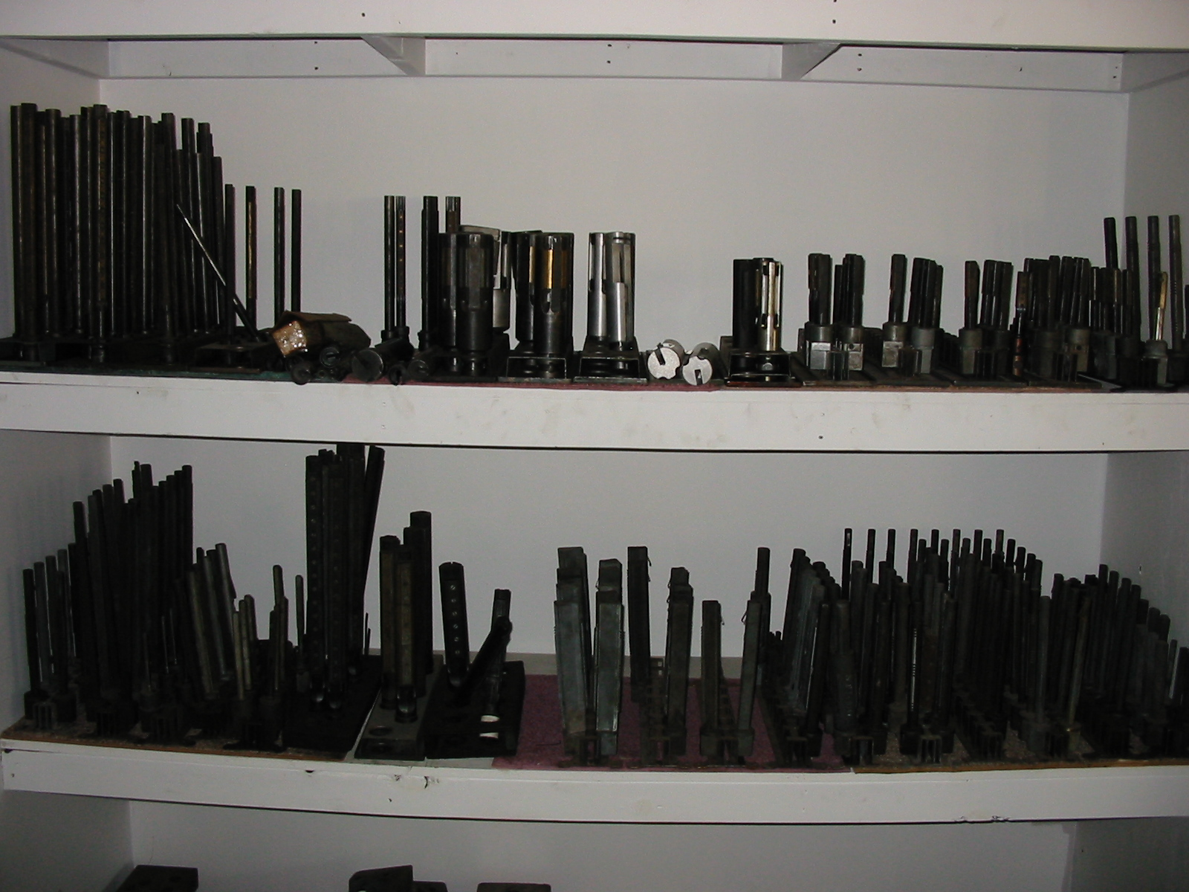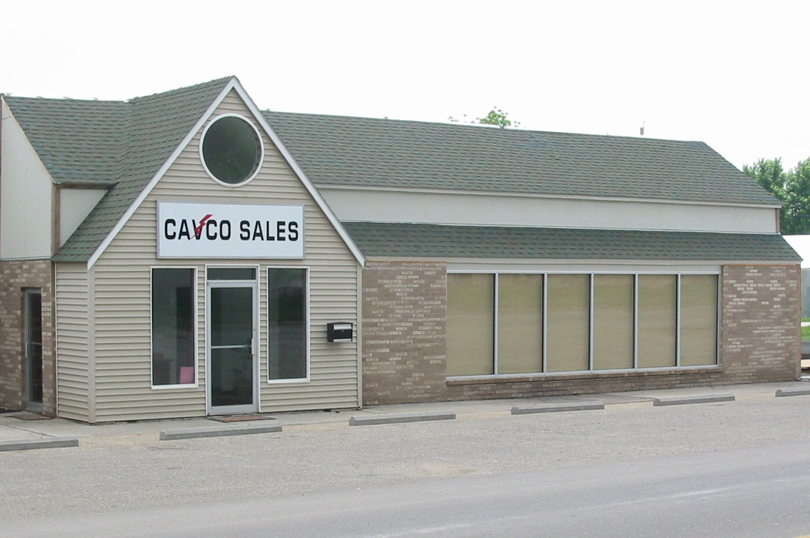

We Also Stock A Wide Variety Of Used & New Machine Parts & Tooling.
We Have A Large Selection Of New & Used Van Norman Boring Bar Parts.
Need A Sunnen Mandrel Give Us A Call.

We Have A Large Inventory Of Used Tooling & Hard To Find Machine Parts

Give Us A Call For Your

Parts & Supply Needs!

Thank You For Your Business From The Cavco Team:

Dan, Cindy, Cameron, Caleb & Jeff

